1. Print the first and last name of the characters and the title of the book that appears on them

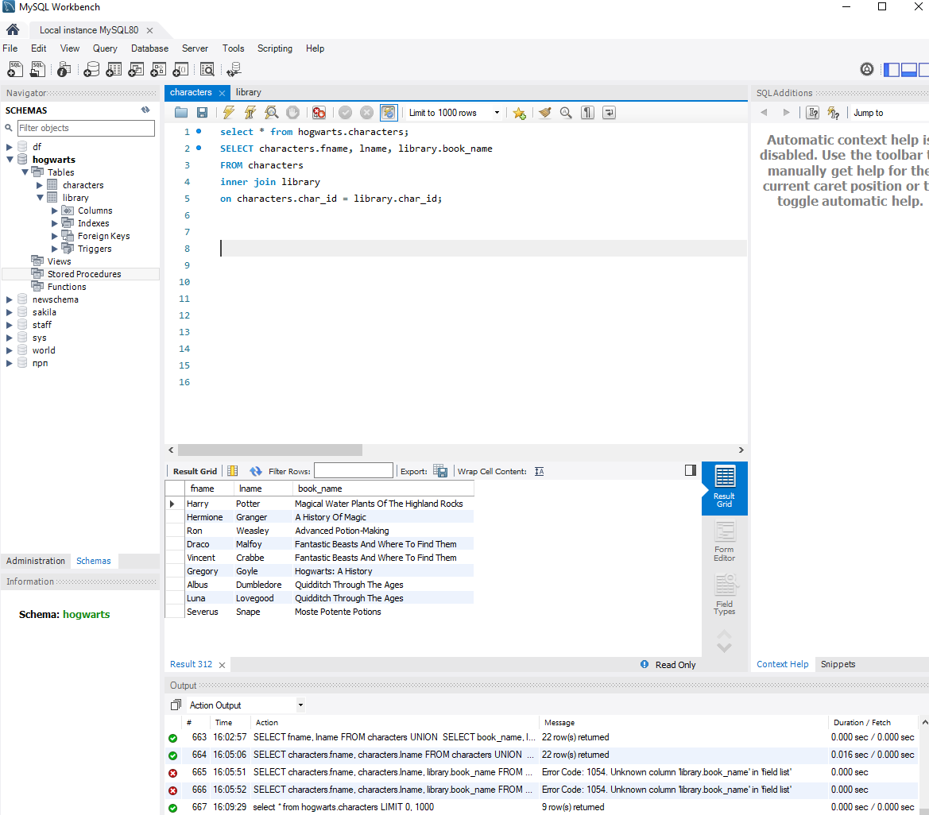

1. Print the characters first name, last name and book title, regardless of whether they have books or not

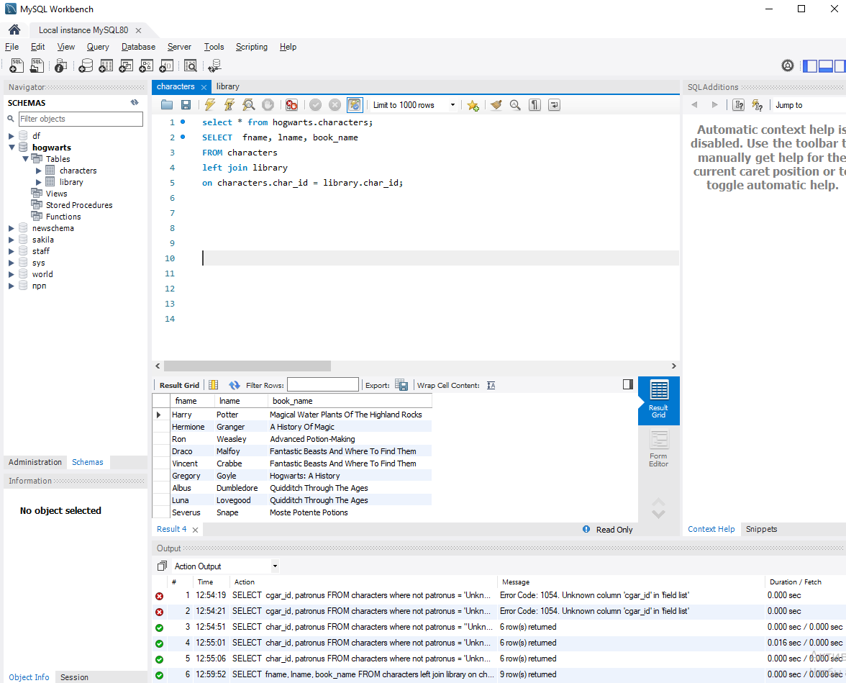

1. Print the title of the book and the name of the patronus, regardless of whether information about the book holder is in the table or not

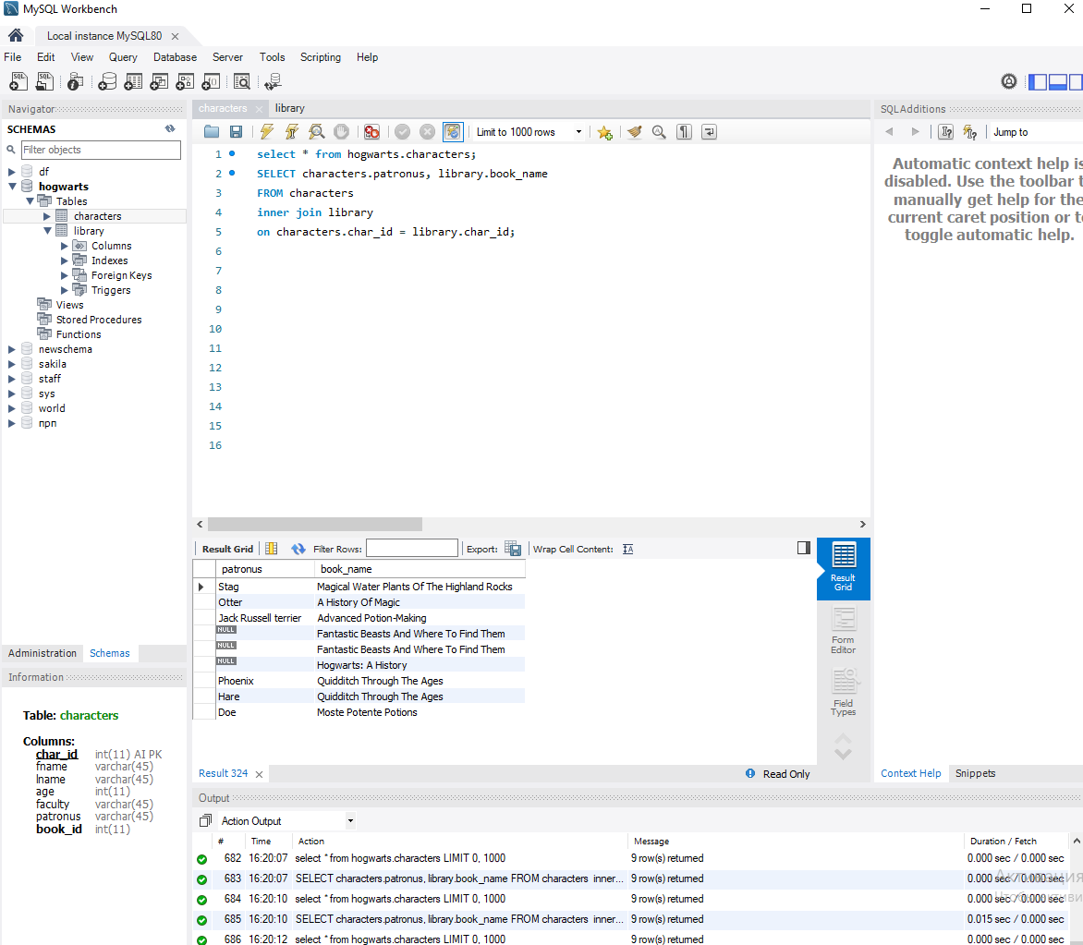

1. Print the first name, last name, age of the characters and the title of the book that is listed on them, provided that all book owners must be over 15 years old

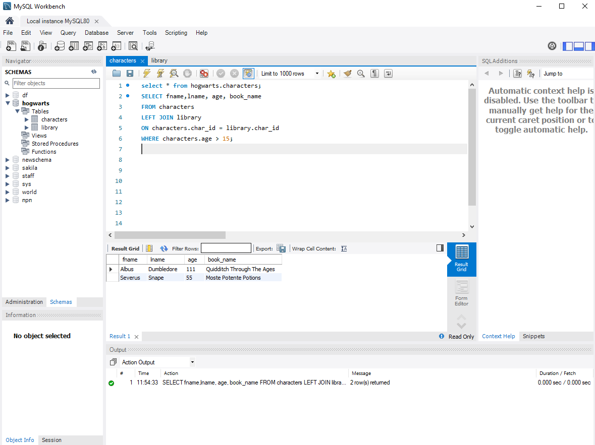

1. Print the character's name, book title, issue date, and completion date, assuming he is under 15 years old and his patronus is unknown

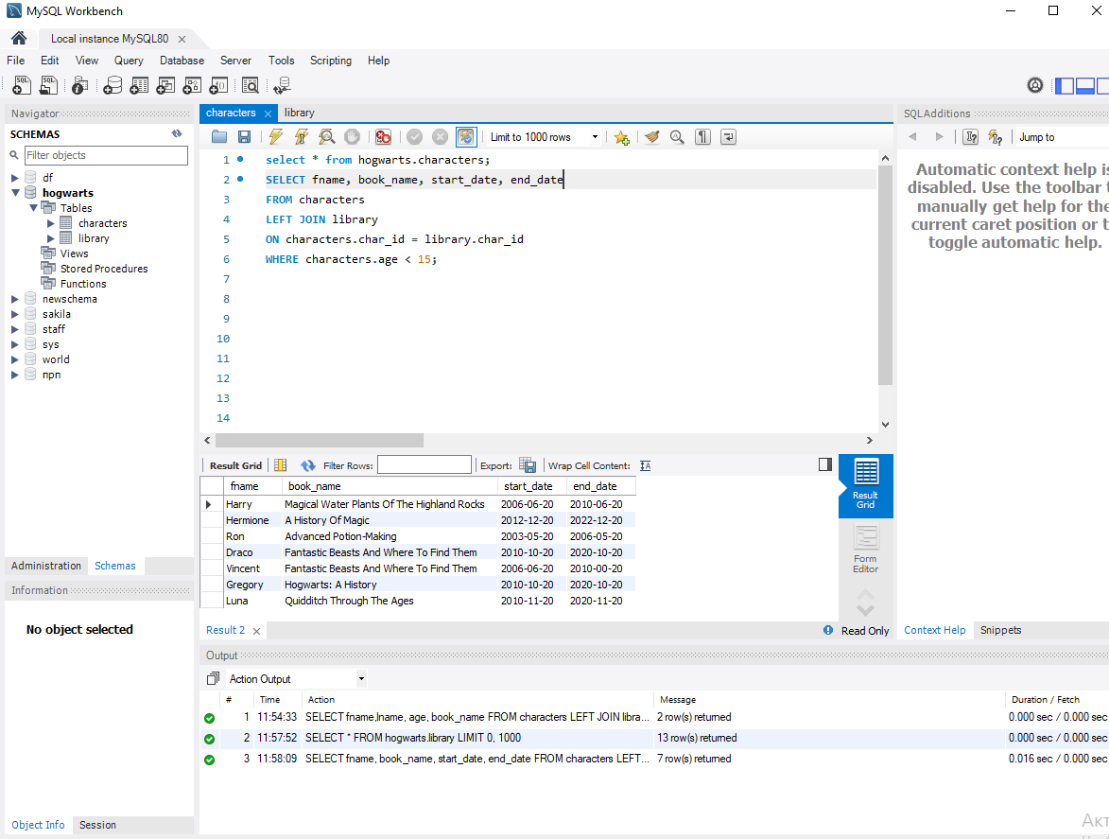

1. Using a subquery, the number of books whose end_date is greater than Hermione's end_date

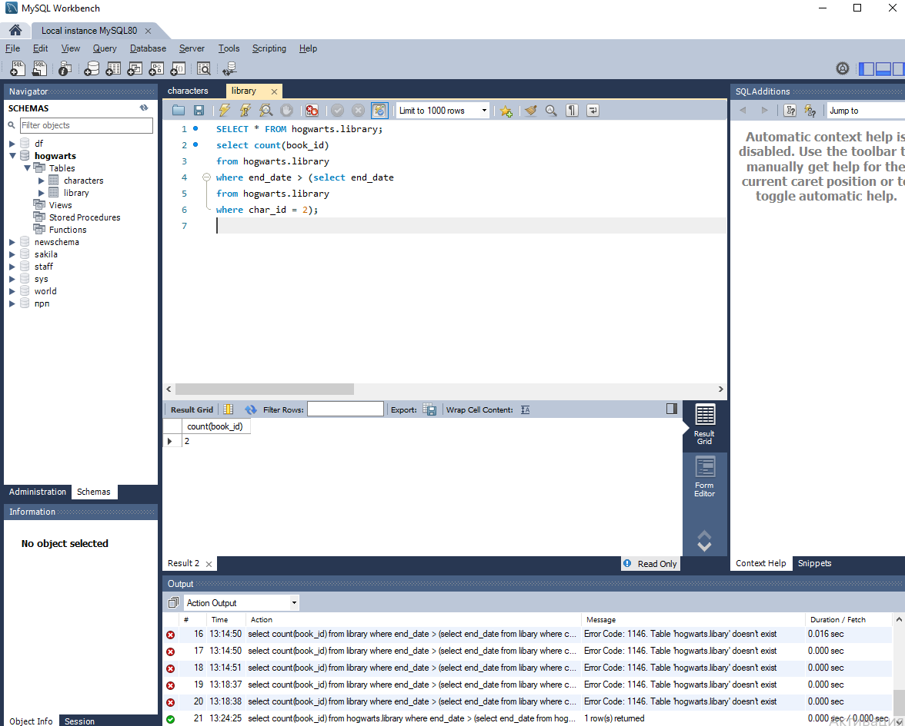

1. Using a subquery, print the names of all patronuses whose owners are older than the age of the character who has the Unknown patronus

